Secure File Access in Azure Blob Storage Using SAS Tokens

1. Abstract
This project is about securely sharing files stored in Azure.
We use Azure Blob Storage to store files. We use a SAS token to give a user temporary access to a file.
We can decide:
- What the user can do — Read, Write, or Delete
- How long they can access the file
- Whether they can access it only through HTTPS
When the SAS expires, the user can no longer access the file.

2. Problem Statement
When we share files in cloud storage, giving users full access can be risky.
For example, if a person only needs to read a file, we should not give them permission to delete or change it.
We need a way to:
- Give users only the access they need.
- Give access for a limited time.
- Stop access automatically after the expiry time.
- Protect the files from unwanted changes or deletion.

3. Objectives
The main objectives of this project are:
- Store files in Azure Blob Storage.
- Create SAS tokens for secure file sharing.
- Set Read, Write, and Delete permissions.
- Set an expiry time for access.
- Use HTTPS and verify expired tokens are denied.

4. Existing System / Problem
In a normal cloud storage system, users may be given more access than they actually need.
For example:
A user only wants to download a certificate.
But if we give them full storage access, they might also be able to:
Read ✅
Write ✅
Delete ✅
This can create security problems.
There is also a problem when access needs to be given only for a short period of time.

5. Proposed Solution
We use Azure Blob Storage + SAS tokens to solve this problem. The process is:
User needs a file
↓
Generate SAS token
↓
Choose permission
(Read / Write / Delete)
↓
Set expiry time
↓
Give SAS URL to user
↓
User accesses the file
↓
SAS expires
↓
Access is denied

6.System Architecture

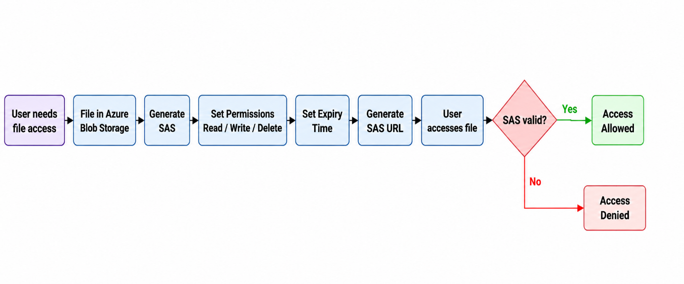

7. Services / Technologies Required
The project uses the following Azure services and technologies:
- Microsoft Azure – Cloud platform used to create and manage the project.
- Azure Storage Account – Provides the storage environment.
- Azure Blob Storage – Stores the project files securely.
- Shared Access Signature (SAS) – Provides temporary and controlled access to files.
- Azure Storage Browser – Used to upload, view and manage blobs.
- Azure Portal – Used to configure the Azure resources.
- GitHub – Used to store project documentation, diagrams and project files.
- Web Browser – Used to test the generated SAS URLs.

8. SAS Permission and Expiry Workflow
User needs file access
↓
File stored in Azure Blob Storage
↓
Generate SAS token
↓
Set required permissions
↓
Set expiry time
↓
Generate SAS URL
↓
User accesses the file
↓
Azure validates the SAS token
If the SAS token is valid:
Access Allowed → Monitoring / Activity Recording
If the SAS token is invalid or expired:
Access Denied → Monitoring / Activity Recording
The SAS token therefore provides temporary access to the required storage resource without giving the user permanent access to the storage account.

9. Implementation
The project was implemented using Microsoft Azure Portal.
Step 1: Create Storage Account
A storage account named sasgov2026kl45 was created in Azure.
The storage account was configured with:
- Standard performance
- Locally Redundant Storage (LRS)
- Secure transfer enabled
- Minimum TLS version 1.2
- Blob anonymous access disabled
- Blob soft delete enabled

Step 2: Create Blob Container
A container named documents was created inside the storage account.
Step 3: Upload Test File
A test file named test-document.txt was uploaded to the documents container.
Step 4: Generate SAS
The Generate SAS option was selected for the uploaded blob.
The following options can be configured:
- Signing method
- Signing key
- Permissions
- Start time
- Expiry time
- Allowed IP addresses
- Allowed protocols
Step 5: Configure Permissions
The required permissions are selected while generating the SAS token.
Examples include:
- Read – Allows the user to read or download the file.
- Write – Allows writing or modifying data.
- Delete – Allows deletion of the blob.
Step 6: Configure Expiry
An expiry time is specified for the SAS token.
For example, a SAS URL can be created that is valid only for a few minutes.
Step 7: Generate and Test SAS URL
Azure generates the SAS token and SAS URL.
The URL is opened in a web browser to verify whether the user can access the file.

10. Expected Results
- The project was tested using different SAS conditions.
- When a valid SAS URL is used, the uploaded file can be accessed successfully.
- When the SAS token expires, Azure rejects the request and displays an authentication error. This confirms that the expiry condition is working correctly.

